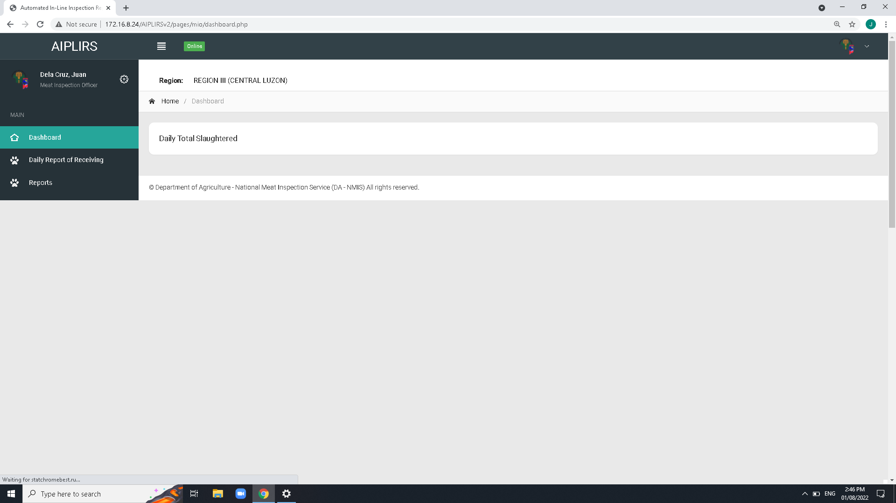

DASHBOARD CARDS : Status, Pending, Ongoing, completed

Resolve: AUGUST 23

Create a summary card for the receiving, fit for slaughter, fit for human consumption

Resolve : august 2, 2022

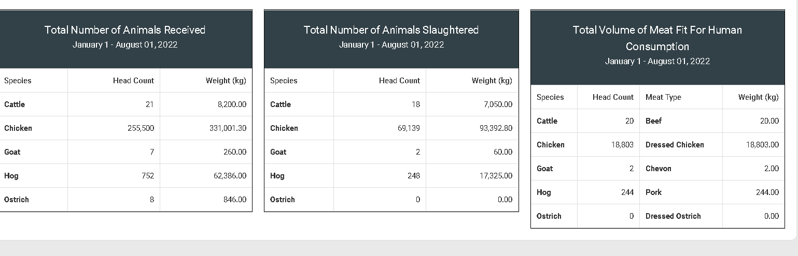

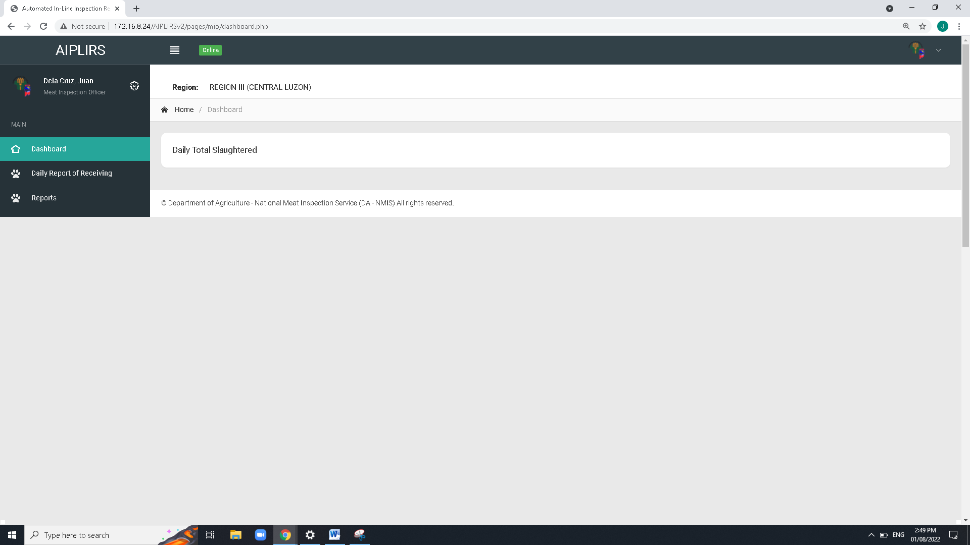

Remove Navigation bar header and breadcrumbs on all pages

Resolve : august 2, 2022

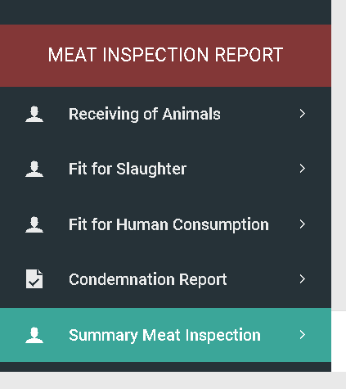

To be added on MIO account sidebar:

Output is the summary on the all Meat establishment assignment base on dates

(suggestions: tick boxes for the Current, previous)

Resolve : august 2, 2022

Make column sticky css from “date and time to species”

Revised: User interface August 8, 2022

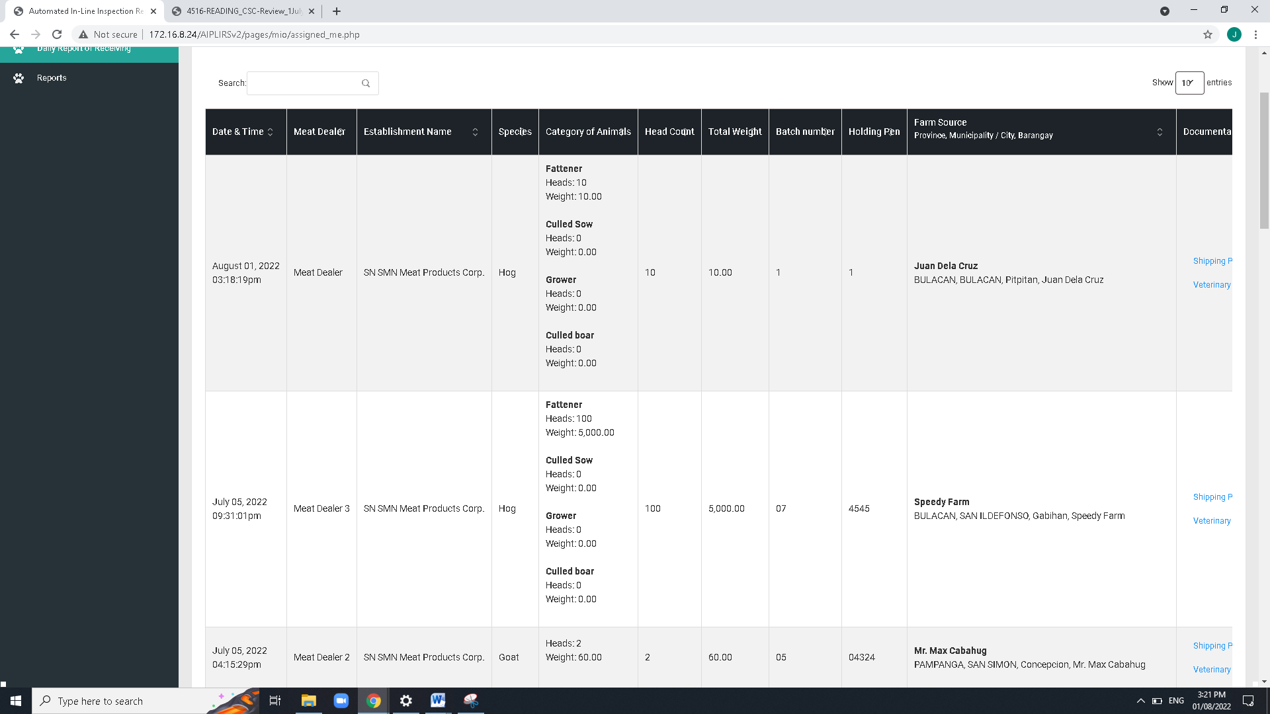

Change header title

Establishment to Meat establishment

Total weight to total weight(kg)

Revised: User interface August 8, 2022

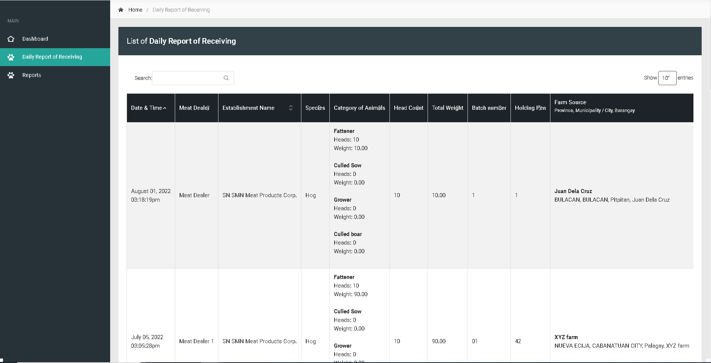

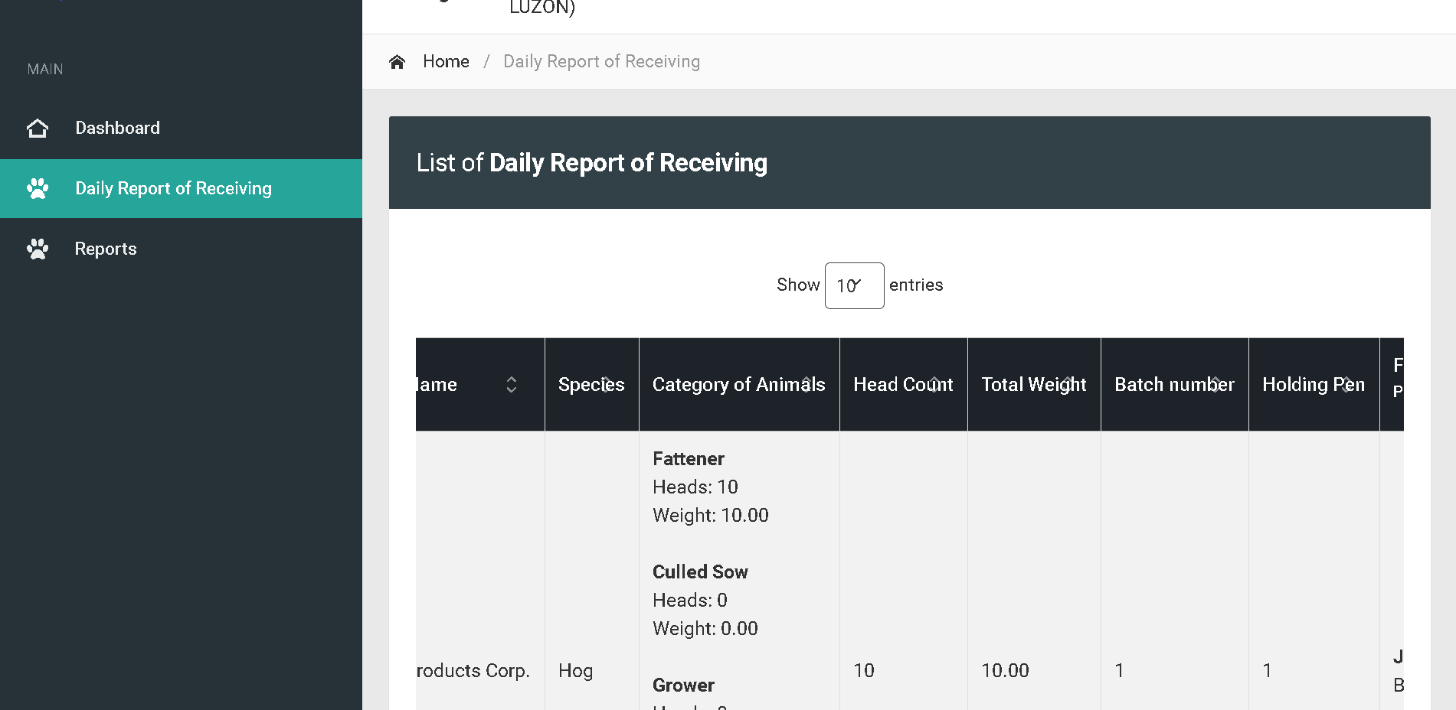

Bactch and holding pen : Text align center

For the column of head count and total weight make it text right

Revised: User interface August 8, 2022

Change title to Daily Receiving of Animals

Revised: User interface August 8, 2022

Change sidebar title to Daily Receiving of Animals

Revised: User interface August 8, 2022

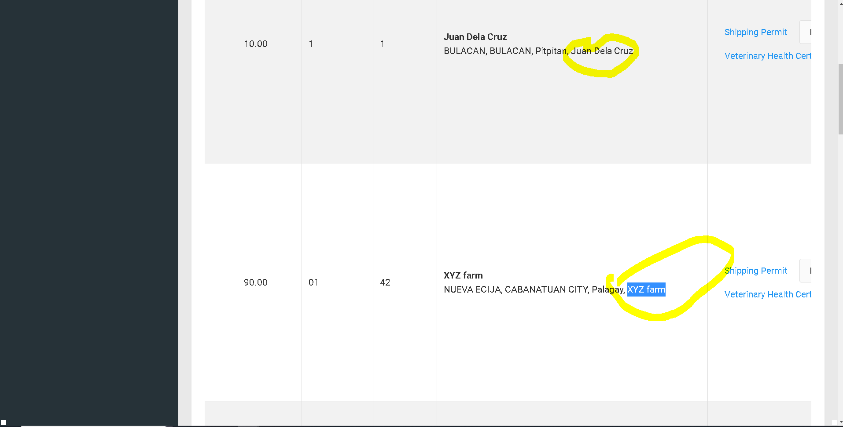

Remove on fetch data of line code

Revised: User interface August 8, 2022

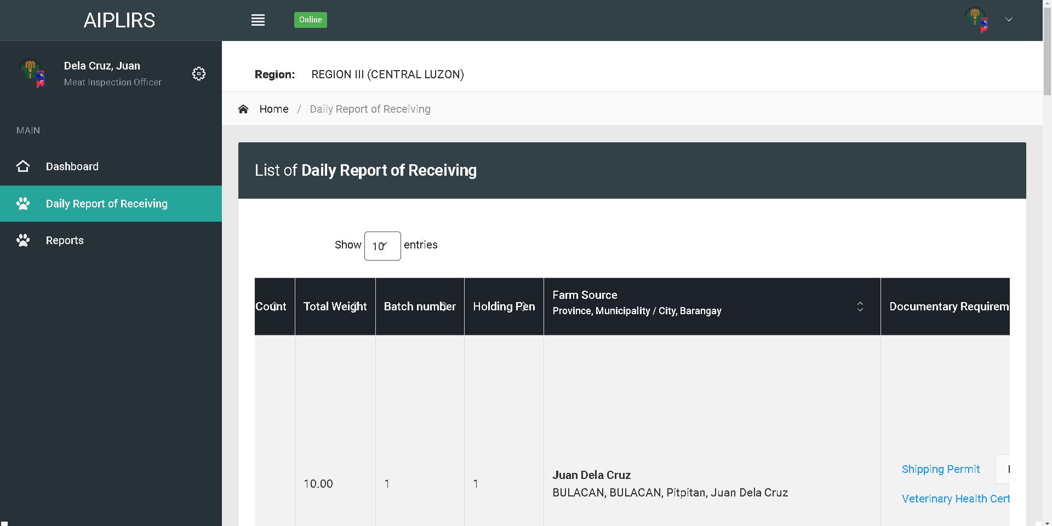

Change address format to “barangay, city, province”

Revised: User interface August 8, 2022

Change table header

Farm Source and Address

Remove indicator

Revised: User interface August 8, 2022

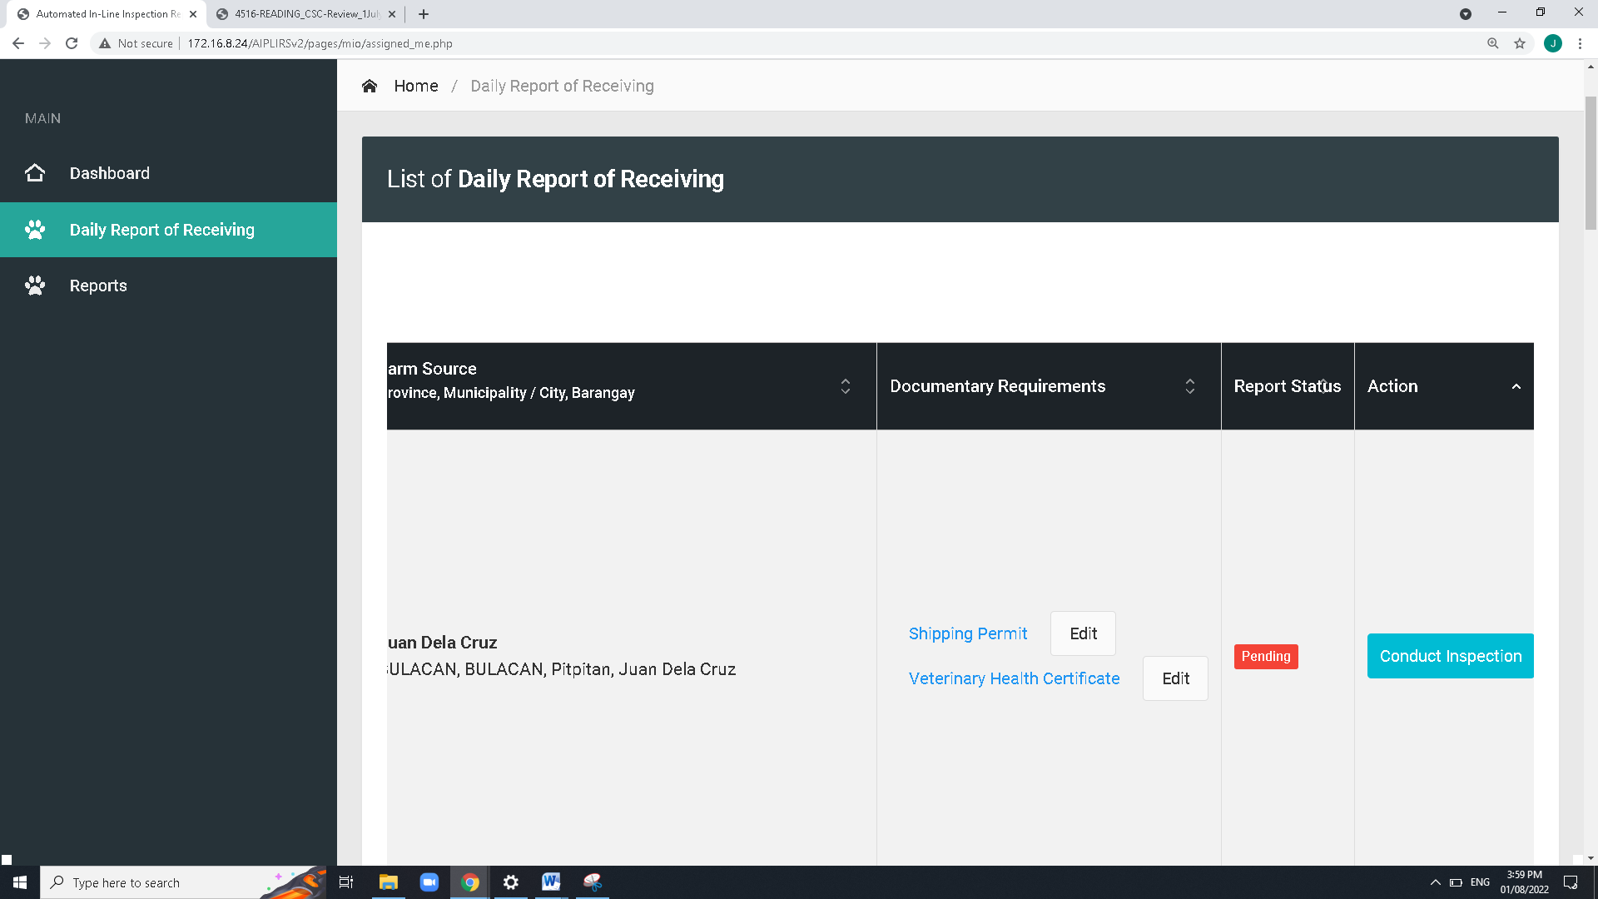

Add approve for the “Request to edit ” in the MIO button actions

Revised: User interface August 8, 2022

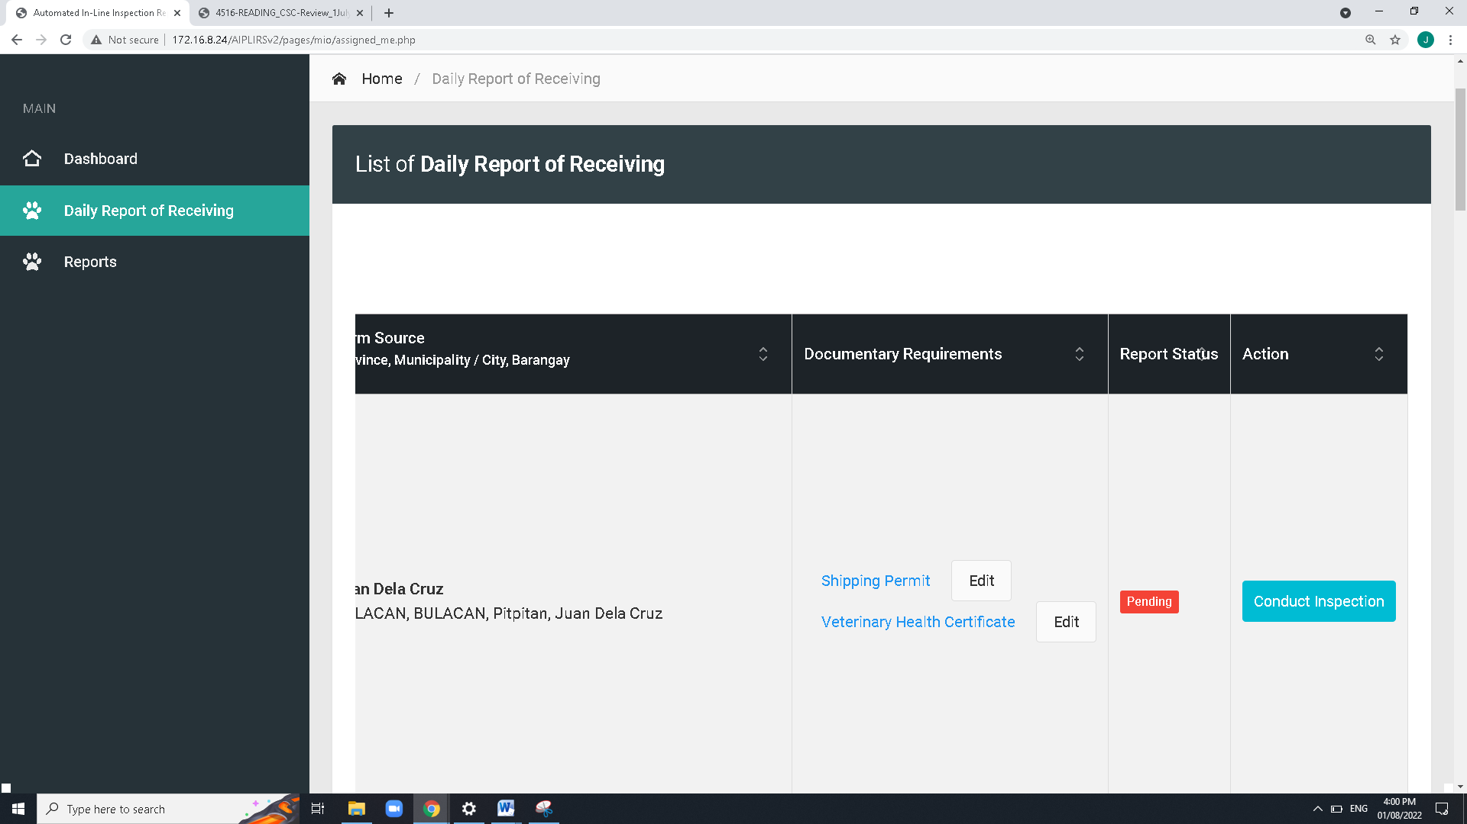

ME: Upload or Captured

Revised: User interface

August 8, 2022

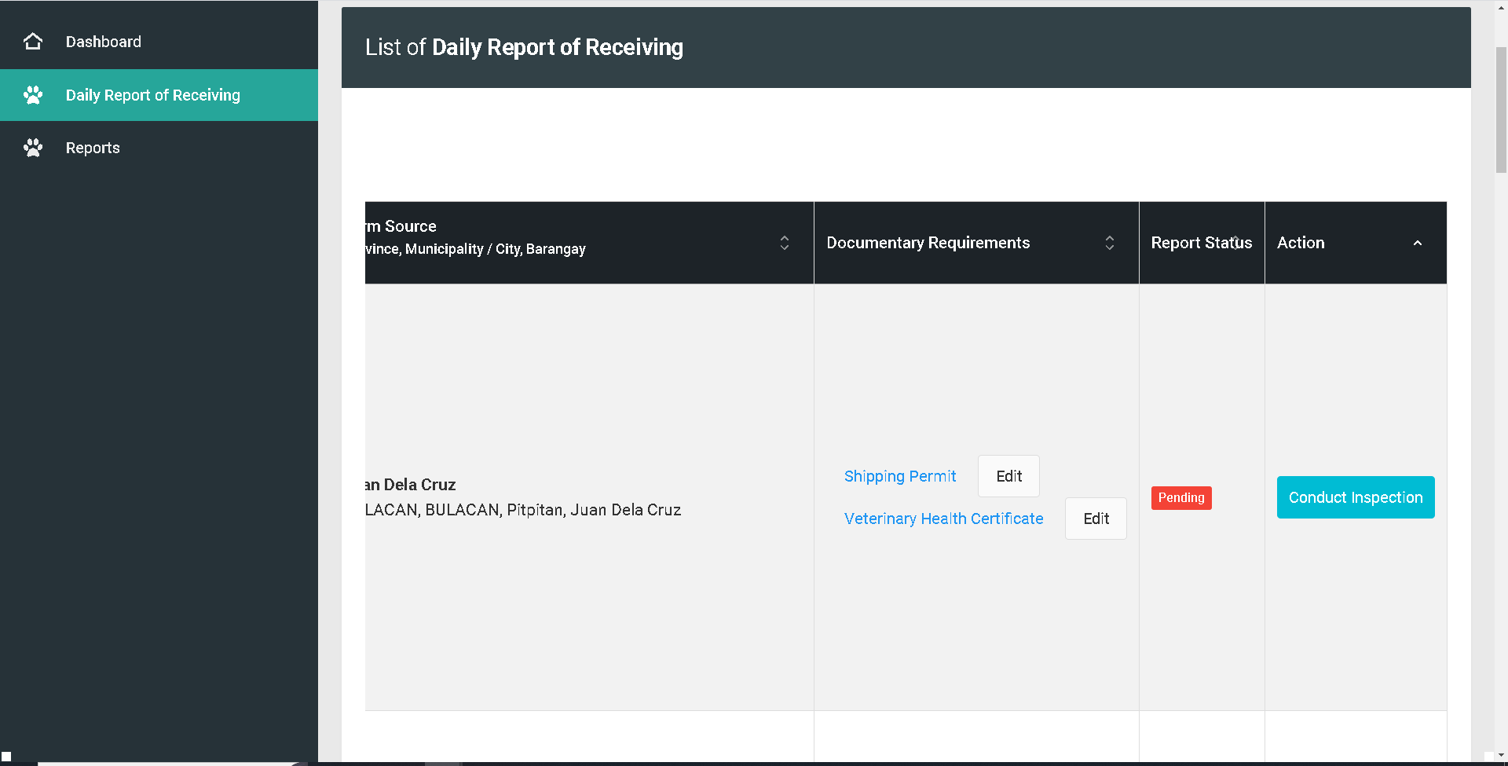

Change edit Accept / Reject

Revised: User interface

August 8, 2022

For the button of the of the shipping permit should change to Accept / Reject. Then system will notifiy the meat establishment for the edit of document

August 8, 2022

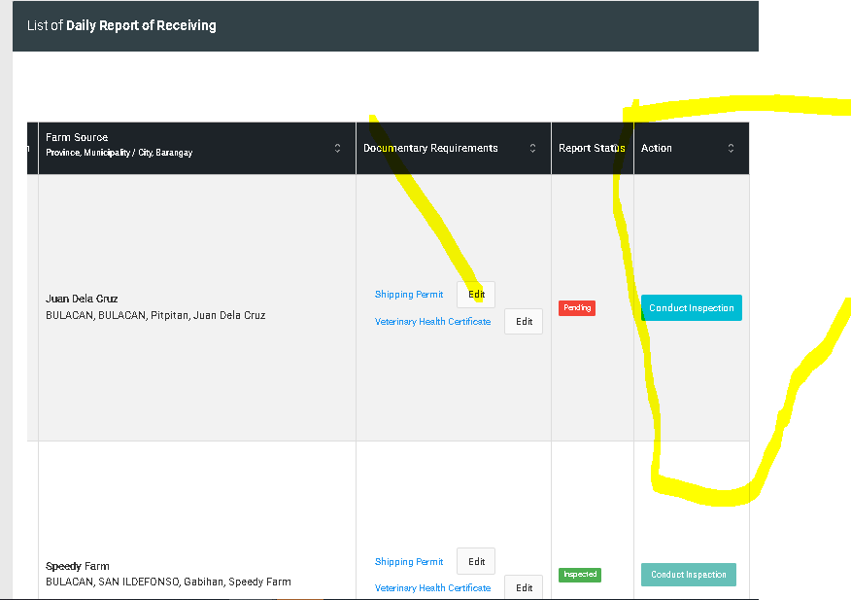

Revised: User interface August 8, 2022

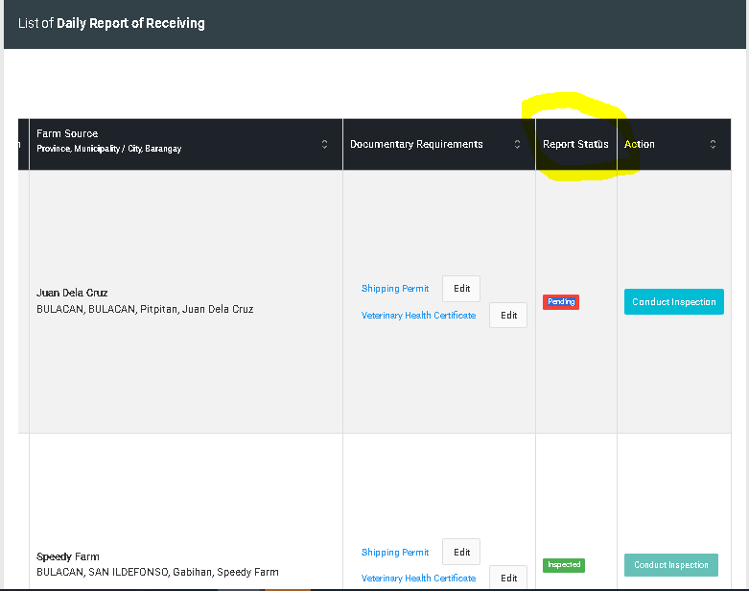

Revised: User interface August 8, 2022

**For the revision of Daily Receiving of animals in MIO account**

**August 5, 2022**

* Order of table (Date & Time, Meat Establishment, Species, Head Count, DRR Details, DRR Status, Inspection Status)
* Add another modal for the viewing of data and take actions
* On **view** button modal change “conduct inspection” to “proceed to inspection” and another button for “request to edit”
* remarks must be visible by clicking the DRR status
* **DRR status**: **Pending**, **For editing, Updated, Completed**.
* **Details of DRR page action**: **proceed to inspection**(DRR status will update to approved), **request to edit**
* **Inspection report status**: **Pending**(upon checking Drr page), **On-going**(if DRR is approved color: orange), completed(Antemortem & postmortem conducted)

**Request to edit DRR** button:

for the reject button after clicking modal will appear and MIO will note the correction of the details specially documentary req.

notification will appear on ME dashboard for the remarks,

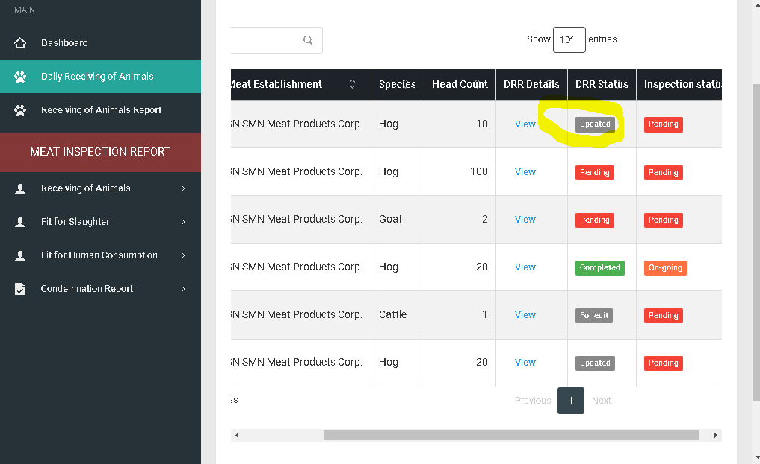

Same with “for editing “ button with modal remark details

Resolve: August 9, 2022

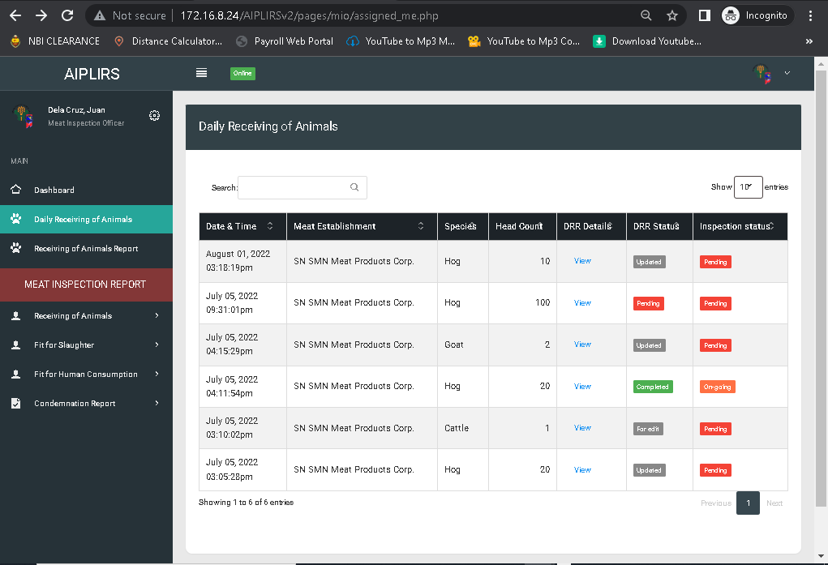

USER’S MANUAL: to be stated by details by details

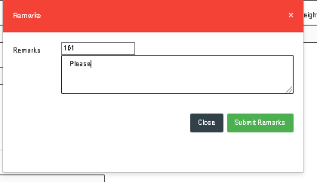

ID Unhidden

Remove remarks on label textarea

Resolve: August 9, 2022

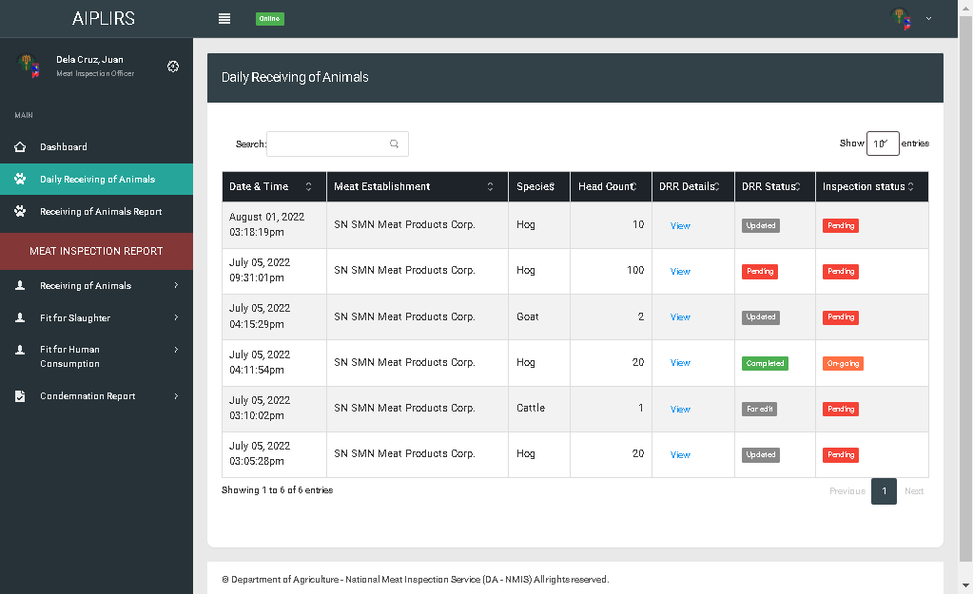

Daily Receiving of animals change to “DRR & Meat Inspection Status”

Resolved: august 9, 2022’’

DRR & Meat Inspection Sta tus change the header

Resolved: august 9, 2022

Receiving of Animals report change to “Daily Meat Inspection Report”

Resolved: august 9, 2022

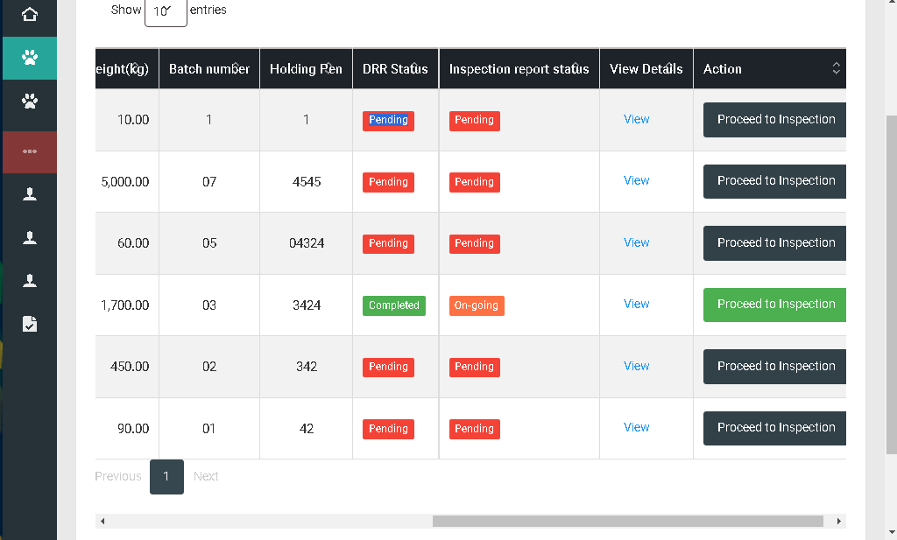

Remove action column meat dealer, total weight, batch numer, holding pen

Change positioning of after head count change header “drr details” button “td” view

Order of the table after drr details “DRR STATUS”, “INSPECTION STATUS”

Resolved: August 9, 2022

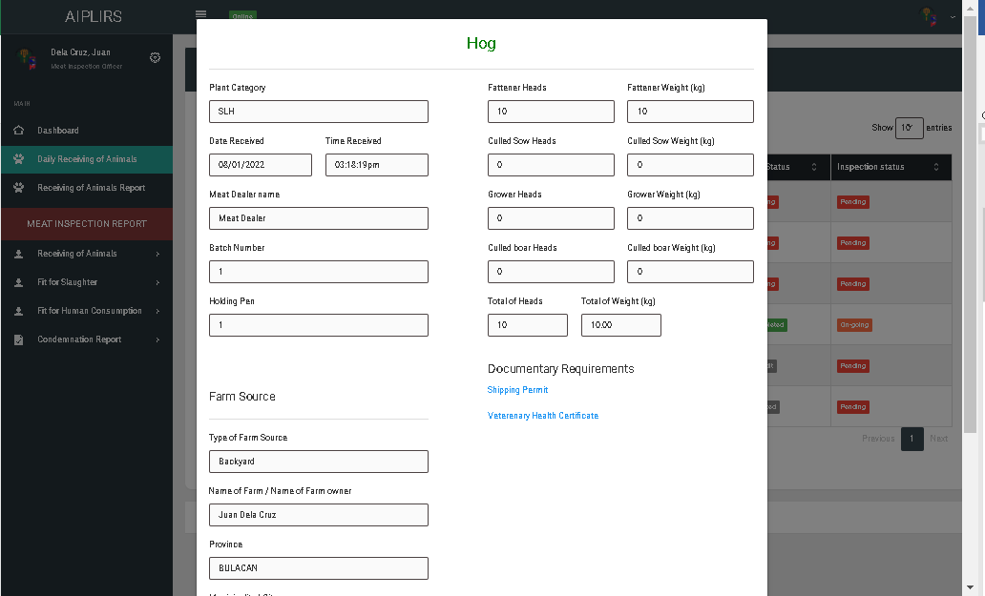

Make a pop up view for the viewing of documentary requirements

Resolve: August 9, 2022

for the batch number and holding pen make it one line to less spacing

Resolve: August 9, 2022

on the category of food animal change the label head count to "total head count" and weight to "Total live weight (kg)"

Resolve: August 9, 2022

Plant category change to “type”

Resolve: August 9, 2022

If the value is "0" hide the fields

Resolve: August 9, 2022

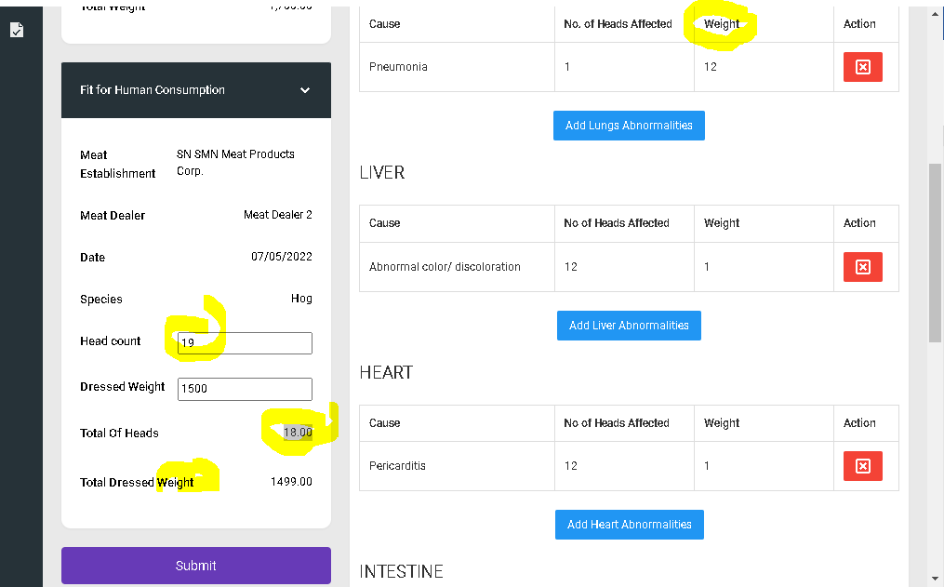

Sytem will be redirected to antemortem

Resolved: August 4, 2022

Change the title to” total head count”

Resolved: August 4, 2022

Head count not be deducted

Resolved: August 4, 2022

Add kg on the weight label

Resolved: August 4, 2022

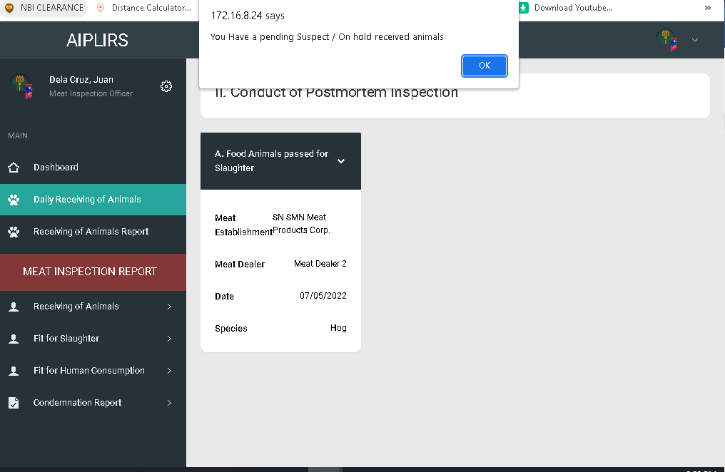

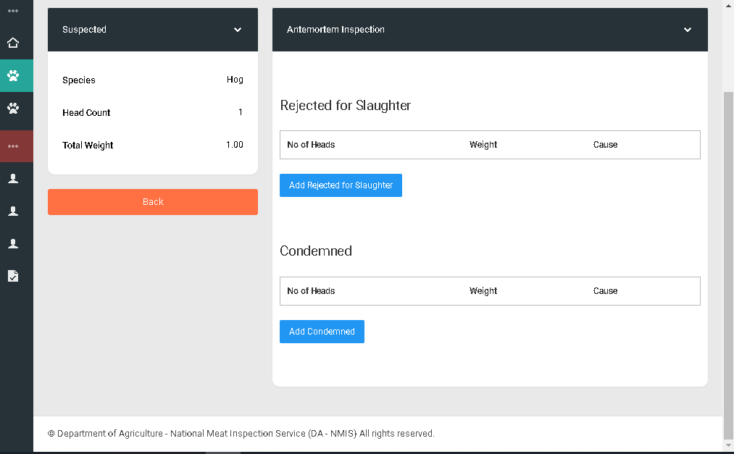

add a button for “Passed for slaughter” or ”Proceed to Postmortem Inspection”

Resolved: August 9, 2022

Change label “Cause” to “Confirmatory Result”

Resolved: August 9, 2022

Change label “No. Of heads” to “No. Of heads affected”

Resolved: August 9, 2022

Change label “Weight” to “Total live weight”

Resolved: August 9, 2022

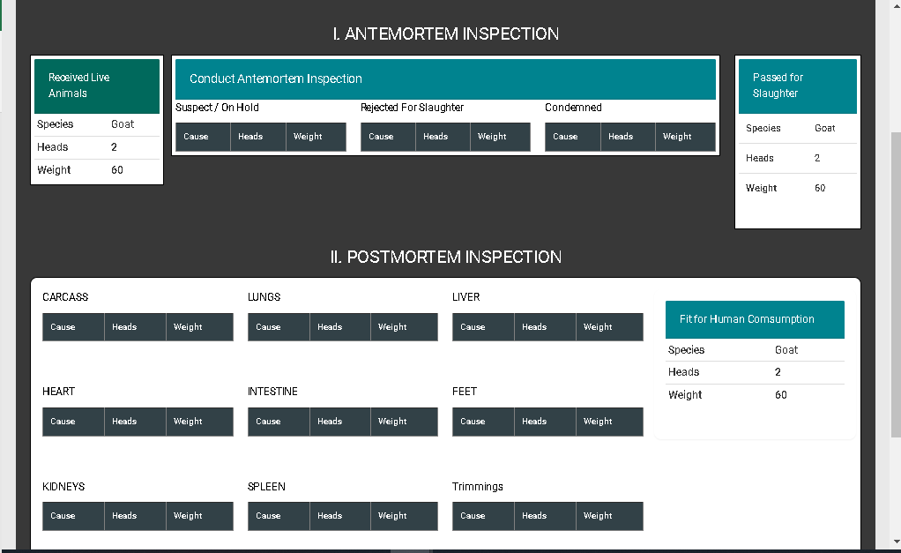

All table header is on centered

Receiving, pass for slaughter , fit for human consumption

total head count

antemortem inspection

Heads to Head Count

Weight to total live Weight (kg)

postmortem inspection

Heads to No. of Heads Affected

Weight to Dressed Weight (kg)

Fit for Slaughter

Heads to Total Head count

Total Live Weight (kg)

Fit for human Consumption

Heads to Total Head count

Total Dressed Weight (kg)

Resolved: August 9, 2022

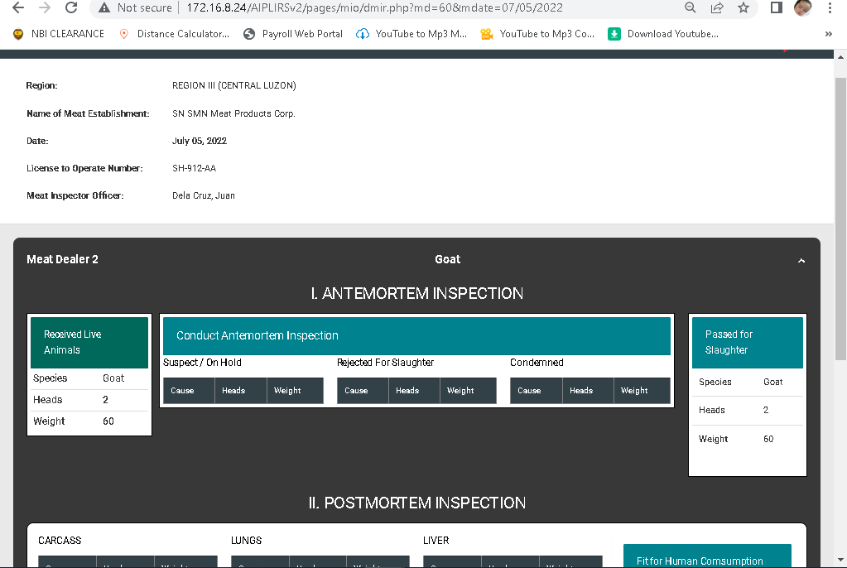

Change label to Receiving of animals

Resolved: august 9 , 2022

Date:

Region:

Meat Inspection Officer:

Segregate into 2 column

Meat establishment name

Lto number:

Resolved: august 9 , 2022

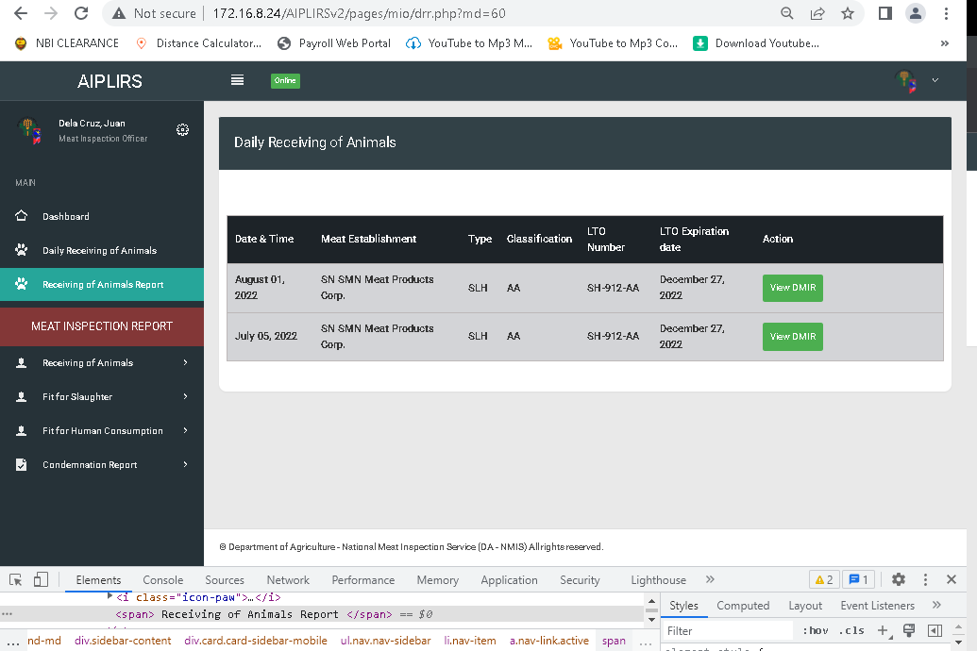

Create a filtering form for the single date and Meat Establishment multiple

Resolved: august 24 , 2022

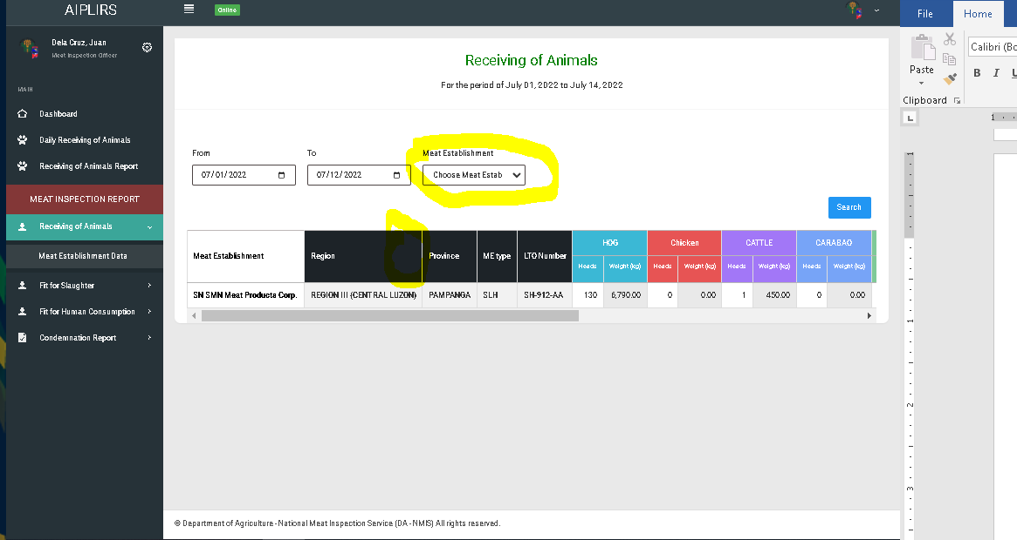

Add tick boxes on meat establishment option for filtering

Resolved: September 2, 2022

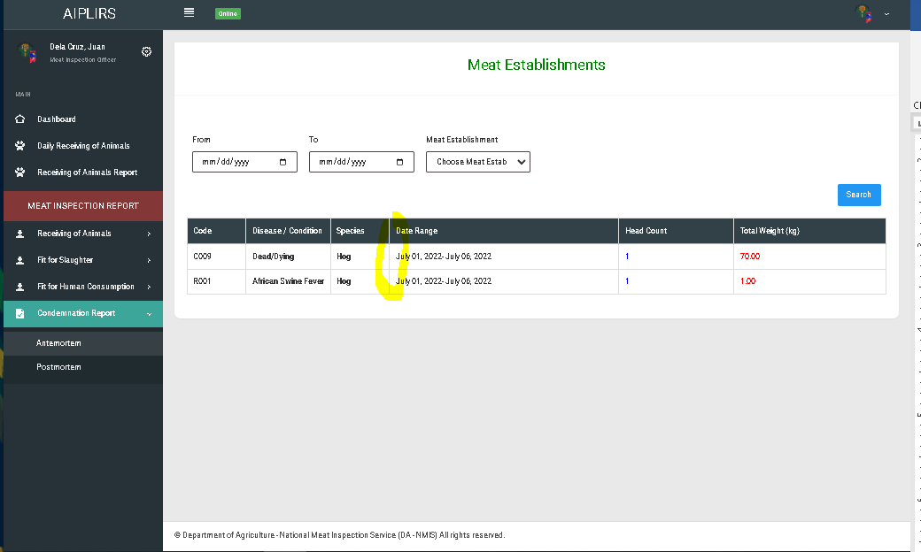

Add column for the judgement

Resolved: September 24, 2022

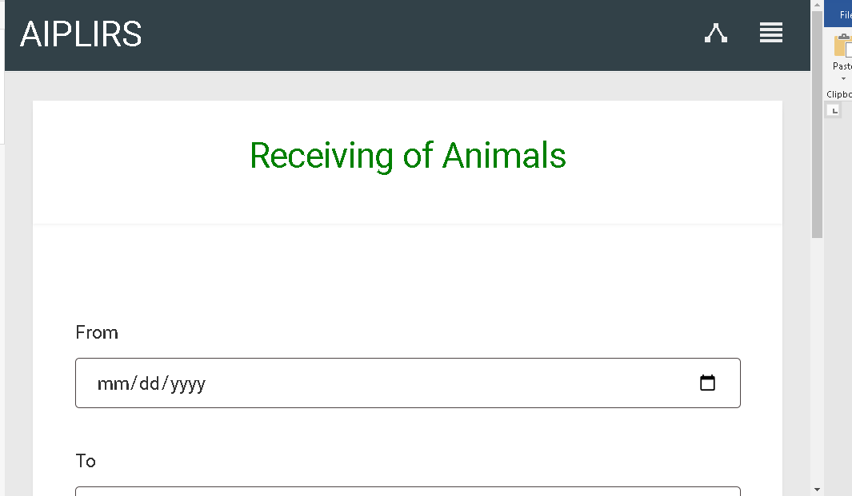

Make the font weight Into bold on all pages

Resolve: August 9, 2022

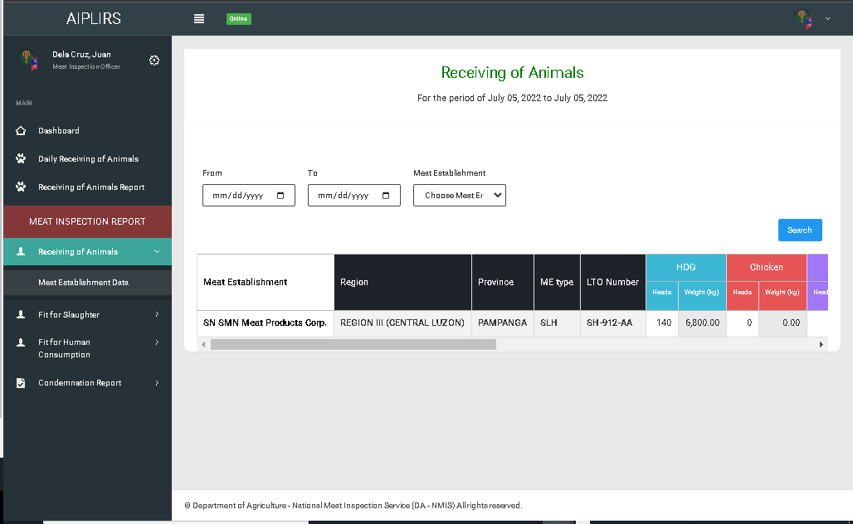

Add tick boxes on meat establishment option for filtering

Resolve: August 9, 2022

On MIO account remove meat inspection report sidebar header add “Summary of Meat Inspection Report

Resolve: August 9, 2022

REMOVE ALL COLUMN WITH 0 VALUE ON ALL SUMMARY USER ACCOUNTS(POSMD, POSMS, MIO, ME)

Pending: for improvement